ANNEX 5
Support Policy Package for Unicorn Enterprises
I. Municipal Level
(I) Development Status, Layout and Advantages
1. Development Status
As of 2022, Beijing boasts 102 unicorn enterprises, with a combined valuation of approximately US$ 276.02 billion, ranking first in both number and valuation among all cities in China. These unicorn enterprises span across 22 different industries, with e-commerce, big data and cloud computing, artificial intelligence, medicine and health, and AI healthcare being the main ones.
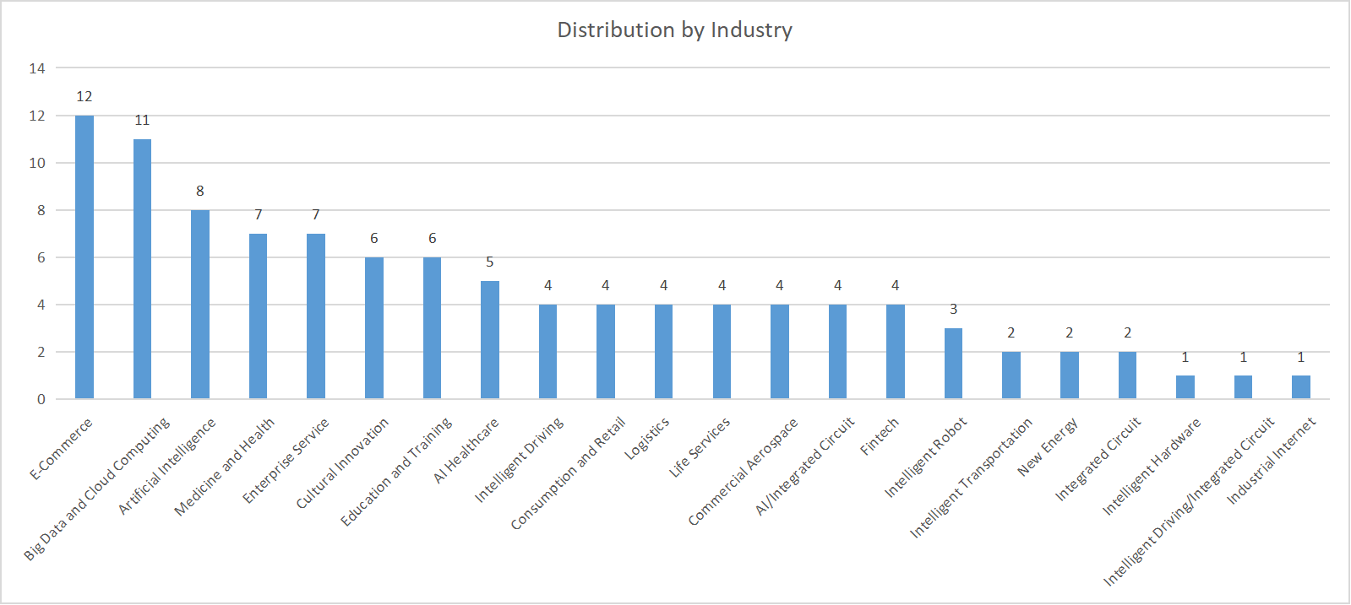
2. Development Layout
As per the Development Plan of the Zhongguancun National Innovation Demonstration Zone During the 14th Five-Year Plan Period, Beijing is committed to supporting the innovation and growth of micro, small and medium-sized technology enterprises through initiatives such as the establishment of the "Golden Seed" start-up fund, providing "universal services+targeted services+equity investment", and increasing funding for the research and development of small and micro enterprises. Additionally, an industry stewardship system will be established for unicorn enterprises to facilitate their close collaboration with universities and research institutes, and promote their strategic positioning within the city. The Plan also aims to support eligible enterprises to obtain high-tech enterprise accreditation through the "approval on filing" method, and further implement tax deductions for research and development expenses and income tax exemptions for high-tech enterprises to encourage their capacity building in innovation.
In 2022, Haidian District and Chaoyang District are home to 72 unicorn enterprises, which account for over 70 percent of the total. Representative companies include Bytedance Co., Beijing Pony.ai Technology Co., Yuanqisenlin (Beijing) Food Technology Group Co., and Keep.
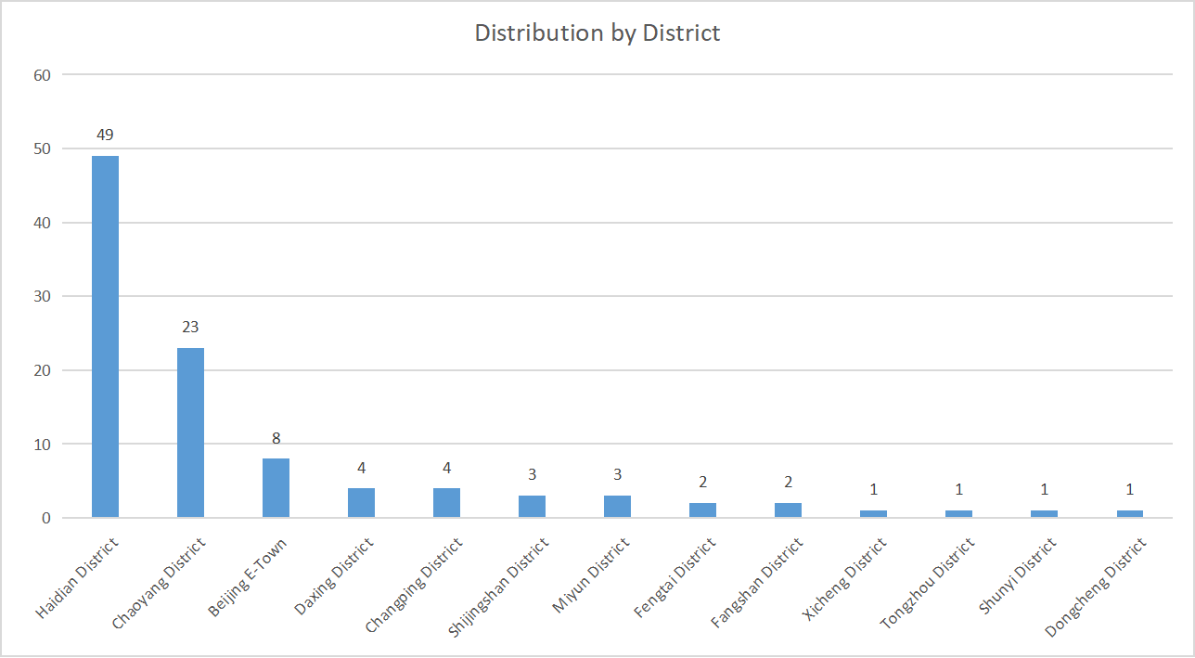
3. Development advantages
(1) Location advantage: Beijing, the capital of China, serves as the center of the country of politics, culture, international communication, and international technology and innovation. It brings together advanced science and technology, abundant financial and cultural resources, talented individuals, and international factors. As a result, Beijing is rapidly becoming a global leader in science and technology innovation, a hub of high-end economic growth, and a preferred destination for innovation and professionals.
(2) Talent advantage: Beijing is a hub for top-tier talents, boasting over 1,000 research institutes and over half of China's Engineering Academy academicians, more than 800,000 undergraduate and graduate students from over 90 universities, nearly 30,000 national high-tech enterprises and over 400,000 high-end professionals. Beijing has attracted and nurtured numerous scientific and technological talents and strategic leaders, while also enhancing various services and support for talents in areas such as household registration, housing, and children's education, creating an increasingly appealing environment for individual development.
(3) Resource advantage: Beijing boasts a culture of vibrant innovation and inclusive entrepreneurship. With numerous startup demonstration centers and incubators, the city offers abundant innovation resources for unicorn enterprises. Beijing has been actively developing itself into a center for technology and innovation, and its key regions remain a leader in innovation. The "three cities and one area" alone account for 31.8 percent of Beijing's enterprises and house approximately 60 percent of the Beijing's research and development personnel and expenses. Beijing is committed to building a competitive technology innovation hub and a fertile land for incubating unicorn enterprises.
(4) Agglomeration advantage: On January 6, 2023, Beijing launched the Zhongguancun Unicorn Enterprise Development Alliance, the city's first social group of unicorn enterprises. The Alliance aims to foster the common growth of unicorn enterprises, facilitate exchanges and cooperation, and provide contact services for unicorns in Beijing. Through in-depth research on the challenges faced by unicorns, the Alliance offers concrete policy suggestions at both the industry and government levels to enhance the independent innovation capabilities of unicorns.
(II) Support Policies
1. Support will be granted for joint technical trouble shooting and improvement of the supply chain and industrial chain. Beijing supports leading enterprises and eligible unicorn enterprises to lead joint technical trouble shooting around the key links of the key industry chain by selecting research and development partners and teams through competition, forming an innovation complex composed of upstream and downstream manufacturers, universities, and research institutes. The support will primarily in the form of equity investment. Relevant municipal platforms shall contribute not more than 30 percent of the total project investment with a maximum amount of CNY 10 million, and hold not more than 30 percent of the shares and avoid being the largest shareholder. If necessary, ex-ante subsidies of up to 10 million can be offered to the project in accordance with relevant procedures.
2. Support will be granted for the establishment of technology innovation centers. Leading enterprises and eligible unicorn enterprises to collaborate with higher education colleges, research institutions, and small and medium-sized enterprises throughout the industry chain to establish such centers. Ex-ante subsidies of up to CNY 20 million per year will be provided for a single technology innovation center, the amount of which should not exceed 30 percent of the total budget for the center's development. The support cycle should not exceed 3 years generally, and the amount of funds for the second and third years will depend on the previous year's performance, with funds being allocated on a selective basis. The cumulative support for 3 years should not exceed CNY 50 million and funds will be used to enhance the innovation capacity building of enterprises.
Source: For more details of items 1-2, see the Funds Management Rules to Promote Innovation Capacities of Enterprises in the Zhongguancun National Innovation Demonstration Zone (Trial).
Contact: Beijing Municipal Science and Technology Commission, and Administrative Commission of Zhongguancun Science Park
Tel: +86-10-55577777

II. District Level
(I) Support Policies of Dongcheng District
1. Unicorn and potential unicorn enterprises selected in the lists of the Great Wall Strategy Consulting, Hurun Research Institute, and other internationally and domestically authoritative organizations will receive a one-time incentive of CNY 3 million and CNY 1 million, respectively.
2. Unicorn, potential unicorn enterprises, and their wholly owned or controlled subsidiaries that have been newly established or relocated to Dongcheng District and leased office space in Beijing will be eligible for a rent subsidy of up to 50 percent of the annual rent for three consecutive years, with a maximum of CNY 3 million per year, depending on their business operations. Seed unicorn enterprises will receive half of the aforementioned subsidies.
3. Unicorn, potential unicorn enterprises, and their wholly-owned or controlled subsidiaries above designated size can receive incentives based on their annual revenue. Specifically, those with an annual revenue of CNY 5 billion, CNY 2 billion, CNY 1 billion, and CNY 500 million are eligible for incentives of up to CNY 5 million, CNY 3 million, CNY 1.5 million, and CNY 500,000 respectively. Seed unicorn enterprises can receive half of these incentives.
4. Unicorn, potential unicorn and seed unicorn enterprises above a designated size are all included in the Database of of Enterprises in High-end, Precision and Sophisticated Industries in Dongcheng District and are subject to comprehensive assessment. For such enterprises with annual operating revenues exceeding CNY 500 million and profits exceeding 100 million, their executives and core teams may be eligible for rewards of CNY 1.5 million and 2.1 million respectively based on their business performance.
5. Enterprises are encouraged to boost their research and development investments. Unicorn, potential unicorn enterprises, and their wholly owned or controlled subsidiaries that are recognized as national high-tech enterprises, will receive subsidies equivalent to 20 percent of the research and development investment that exceeds the national high-tech recognition standards for three years from the year of recognition. The maximum annual subsidy for a single enterprise is CNY 2 million. Seed unicorn enterprises are eligible for half of the aforementioned subsidies.
6. Support will be provided for unicorn and potential unicorn enterprises to hire global talents by facilitating an expedited process of household registration for senior executives and core technical professionals who meet the talent introduction requirements of the Beijing Municipality and Dongcheng District. Quota for household registration and working residence permits will be adjusted for fresh graduates based on the enterprise's operation and growth potential.
Source: For more details of items 1-6, see the Measures to Introduce and Develop Unicorn Enterprises in Dongcheng District (Trial).
Contact: Dongcheng District Development and Reform Commission
Tel: +86-10-87160667

(II) Support Policies of Xicheng District
1. Enterprises are encouraged to carry out independent innovation. Companies that establish their own research and development institutions and meet the requirements for national-level and Beijing-level engineering (technology) research centers, key laboratories and other innovation platforms, or receive national and Beijing-level science and technology awards, will receive a one-time financial incentive after verification. The total annual incentive funds for such enterprises will not exceed CNY 1 million.
2. Incentives will be provided for innovative and entrepreneurial talents by leveraging the early and pilot policies and measures of talent management reform in the Zhongguancun National Innovation Demonstration Zone. The policies and measures are to optimize the talent innovation and entrepreneurship ecosystem, assist enterprises in attracting and retaining talents, and create a favorable environment for innovation and entrepreneurship.
(1) Outstanding talents who have won national, Beijing-level and Zhongguancun-level innovation and entrepreneurship awards will receive an incentive of up to CNY 1 million.
(2) Enterprises will receive a maximum annual subsidy of CNY 300,000 for talents' housing based on their operations.
(3) Integrated talent services will be enhanced by providing high-quality and efficient services, including talent introduction, Beijing work residence permits, and household registration for non-Beijing residents, for qualified enterprises in the park.
Source: For more details of items 1-2, see the Regulations of Xicheng District,Beijing to Support Independent Innovation in the Xicheng Park of Zhongguancun Science Park.
Contact: Xicheng Park Administrative Commission, Zhongguancun Science Park
Tel: +86-10-68336192

3. Enterprises that have been awarded the "Small Giant" and "Unicorn" titles by the Ministry of Industry and Information Technology as National Specialized and Sophisticated Enterprises that Produce New and Unique Products will be eligible for a one-time incentive of CNY 300,000.
4. "Unicorn" enterprises, hidden champions, listed enterprises, and enterprises proven to be with significant influence or outstanding contributions, may choose any natural year within three consecutive years from the date of registration to receive a one-time incentive of up to CNY 10 million.
Source: For more details of items 3-4, see the policy interpretation of the Regulations of Xicheng District,Beijing to Support Independent Innovation in the Xicheng Park of Zhongguancun Science Park.
Contact: Xicheng Park Administrative Commission, Zhongguancun Science Park
Tel: +86-10-68336192

(III) Support Policies of Fengtai District
1. Efforts will be made in building a "1+3" cluster of unicorn enterprises to boost their concentrated development. The cluster covers an area of 4 million square meters, and composes one main base, the Beijing Kandan Unicorn Innovation Base (including Fengtai Innovation Center and Fengtai Aerospace Innovation Center, with a building area of about 1 million square meters), and three bases including the Garden Expo Digital Economy Industrial Park (with a building area of about 1 million square meters), the South Central Axis Dahongmen New Business District (with a building area of about 1 million square meters) and the Lize Financial Business District (with a building area of about 1 million square meters).
2. More incentives and support will be provided for unicorn enterprises. The government of Fengtai District plans to invest CNY 1 billion annually to provide incentives and subsidies for unicorn enterprises in areas including spatial carriers, technological innovation, commercialization of technological achievements, listing subsidies, individual income tax for executives, and fixed asset investment.
3. A service mechanism will be created to facilitate the listing of unicorn enterprises. This can be achieved by establishing dedicated service teams that provide "one-to-one" counseling throughout the entire listing process. Additionally, a maximum of CNY 10 million will be allocated to support the listing of unicorn enterprises, and investment and guidance funds can be established to further assist in this process.
4. Support will be granted to enhance talent introduction for unicorn enterprises. To facilitate the recruitment of talents in unicorn enterprises, Fengtai will allocate not less than 200 Beijing household registration quotas to them each year, and assist employees and foreign workers in obtaining necessary documents such as the "Beijing Work Residence Permit" and "Work Permit for Foreigners". Additionally, the District will provide 5,000 sets of houses specifically for targeted talents in unicorn enterprises. To further incentivize innovation, the government will offer up to CNY 2 million in rewards to outstanding innovation teams and talents included in the "Fengze Plan". Furthermore, priority and streamline services for children's education, medical care, and government affairs will be offered for these talents.
5. Support will be provided for unicorn enterprises to explore innovative application scenarios. The support will assist in the launch and marketing of their first products, and facilitate the expansion of their market presence. Priority access to major projects invested by the government of Fengtai District, such as application scenario plans and emerging infrastructure, will be given to unicorn enterprises. Additionally, new technologies, products, and models of unicorn enterprises will be given priority for promotion and demonstration.
6. An innovation and entrepreneurship ecosystem for unicorn enterprises will be developed by establishing the "Unicorn Entrepreneurs Association", facilitating communication between the government and enterprises, and efficiently allocating talent, technology, financial resources, and market opportunities. Additionally, high-quality commercial, cultural, and sports facilities will be provided to support unicorn enterprises and foster a dynamic innovation atmosphere.
Source: For more details of items 1-6, see the Measures to Support the Cluster Development of Unicorn Enterprises in the Fengtai District.
Contact: Fengtai Park Administrative Commission, Zhongguancun Science Park
Tel: +86-10-83897601

Note: If a single entity is eligible for multiple support policies, the most favorable policy shall apply. The responsibility to interpret each specific policy shall be borne by the issuing agency.

