ANNEX 1
Support Policy Package for Development of International Center for Technology and Innovation

I. Development Positioning, Layout and Goals
(I) Development positioning
The package is a part of the efforts to build national strategic technology forces and strengthen the leading role of main platforms and fronts for technology and innovation. It will help implement the strategic action plan for building Beijing into one of the first international centers for technology and innovation, and provide strong support for building a world-class, harmonious and habitable municipality, achieving technological self-reliance at a high level, and rejuvenating China with technology.
(II) Development layout
The blueprint of "three cities and one area" will be implemented to build Zhongguancun Science City into a science city topping the world, build Huairou Comprehensive National Science Center (Huairou Science City) into a world-class original innovation carrier adapted to national strategic needs, and Future Science City into a globally leading platform for technological innovation, a pilot zone for collaborative innovation, and a model city for innovation and entrepreneurship, and give full play to the industrial base advantages of Beijing Economic-Technological Development Area and Shunyi District, which are expected to actively carry on the spillover of innovation achievements in the three science cities, and build a main front for high-end, precision and sophisticated industries and a demonstration area for the transformation of technological achievements.
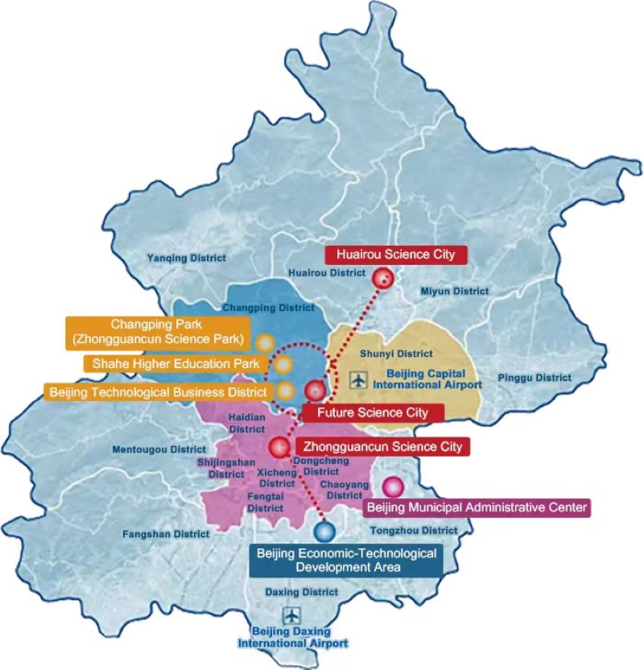
(III) Development goals
By 2025, Beijing will basically become an international center for technology and innovation and a major science center and a prime innovation platform in the world.
1. Make progress in the development of the center for technology and innovation. A systematic layout of strategic technological forces will basically take shape, covering national laboratories, national key laboratories, comprehensive national science centers, new research and development (research and development) institutions, high-level universities and institutes, and leading high-tech enterprises, and the proportion of research and development expenditures of the whole society in regional GDP will remain at 6 percent approximately.
2. Achieve breakthroughs through the bottleneck of core technologies. High-end, precision and sophisticated industries will keep growing, and the development of future industries with a high growth rate and great potential will speed up. The value added of high-tech industries will be over CNY 1.2 trillion in 2025, and the average annual growth rate of digital economy will be kept at about 7.5 percent. The total revenues of enterprises in Zhongguancun National Independent Innovation Demonstration Zone will grow about 8 percent on average annually, and the volume of transactions in technology contracts will exceed CNY 800 billion.
3. Obtain productive results in creating an innovative ecosystem. The innovation and entrepreneurship ecosystem will be constantly optimized, and the rule of law in intellectual property rights will be significantly improved, with the public noticeably more aware of respecting and protecting intellectual property rights. A more favorable atmosphere will be created for venture capital/private equity (VC/PE) investment, and a more convenient business environment will be built. The ability to allocate resources internationally will be stronger, and innovation factors such as human resources, technology, capital and data will flow more smoothly. International cooperation and exchanges in science and technology will be enhanced in all aspects, making Beijing an important node in the global innovation network.
Source: For details of items 1-3, see the Plan of Beijing Municipality on Developing into an International Center for Technology and Innovation During the 14th Five-Year Plan Period.


II. Support Policies
1. Support technology-based small and micro enterprises to innovate key technologies
To support innovation capacity building for technology-based small and micro enterprises in the field of high-end, precision and sophisticated industries, ex-post financial support at either of the following two levels will be offered to the enterprises as a subsidy according to the year-on-year increment of their research and development expenses in the latest fiscal year.
(1) Financial support of no more than CNY 300,000 will be offered to enterprises whose year-on-year increment of research and development expenses is CNY 5 million or more;
(2) Financial support of no more than CNY 200,000 will be offered to enterprises whose year-on-year increased amount of research and development expenses is CNY 1 million or more but less than CNY 5 million;
(3) Financial support of CNY 300,000 at most will be offered to enterprises which won an award in China Innovation and Entrepreneurship Competition, China Innovation Challenge and Zhongguancun International Frontier Technology Innovation Competition.
2. Support the development of cutting-edge technology enterprises
High-quality start-up enterprises in key and core technology will be explored and fostered. They will be supported by means of ex-ante subsidy plus equity investment. In the first year, the amount of support is not more than CNY 2 million. In the second year, for the enterprises which develop well and reach all their assessment indicators, financial support of not more than CNY 3 million will be offered, and for those develop satisfactorily, reach their innovation indicators but fail to reach their economic indicators, not more than CNY 1 million will be offered. In the third year, the support may be continued in the form of equity investment. Relevant municipal-level platforms may contribute not more than CNY 15 million to such enterprises. They shall not hold more than 30 percent of the shares or become the largest shareholder in such enterprises.
3. Support enterprises to generate disruptive technological innovation
Enterprises will be supported to work together for disruptive technological innovation and commercialize their innovation achievements in Beijing. The supported will be granted by means of ex-ante subsidy plus equity investment. In the first year, the amount of support is not more than CNY 2 million. In the second year, financial support of not more than CNY 5 million will be offered according to the fulfillment of performance targets. In the third year, such enterprises will be supported in the form of equity investment. Relevant municipal-level platforms may contribute not more than CNY 30 million to such enterprises. They shall not hold more than 30 percent of the shares or become the largest shareholder in such enterprises.
4. Support leading enterprises to launch the "Strong Chain Project"
Leading enterprises and eligible unicorn enterprises will be supported to take the lead in making technological breakthroughs jointly with others and improve the industrial chain and supply chain. Such enterprises will be preferentially supported by means of equity investment. Relevant municipal-level platforms may contribute an amount not more than 30 percent of total project investment. The contribution shall not exceed CNY 10 million, account for more than 30 percent of the shares in such enterprises or make the platform the largest shareholder of such enterprises.
5. Support leading enterprises to take the lead in building the center for technology and innovation
Leading enterprises and eligible unicorn enterprises will be supported to take the lead in building the center for technology and innovation. The support will be granted by means of ex-ante subsidy for a period of not more than 3 years. The annual support amount for a single center for technology and innovation will be 30 percent of the total construction budget of the center but not more than CNY 20 million. In the second and third years, the support will be subject to the operation performance assessment results in the previous year. The cumulative support in the three years will not exceed CNY 50 million.
6. Support the market debut of innovative products
Support will be granted for the debut application of innovative products in the form of ex-post subsidy. Each enterprise with the best product application results will be granted an amount accounting for 30 percent of the value of market debut contract but not more than CNY 5 million in the case of international innovative products or not more than CNY 3 million in the case of domestic innovative products.
7. Support demonstration projects for key application scenarios
Support will be granted for the development of application scenarios in key industries in the form of ex-post subsidies. An amount equal to 30 percent of the project contract value but not more than CNY 10 million will be offered to project undertakers subject to different standards.
Source: For details of items 1-7, see the Measures of Zhongguancun National Independent Innovation Demonstration Zone for the Management of Funds Supporting Enterprises’ Innovation Capacity Building (Trial).
Contact: Beijing Municipal Science and Technology Commission, Administrative Commission of Zhongguancun Science Park
Tel: +86-10-55577777

8. Support the development of proof-of-concept platform for technological achievements
Support will be granted for the development of third-party proof-of-concept platforms in the field of high-end, precision and sophisticated industries. Usually, the support period will be no more than three years. The total support amount for a single platform will be not more than CNY 15 million, and the annual support amount will not exceed 30 percent of the platform's development budget for the year.
9. Support micro, small and medium-sized enterprises to transform high-tech results
Micro, small and medium-sized enterprises will be supported in transformation, mass production and marketing of high-tech achievements. The micro, small and medium-sized enterprises responsible for the transformation of technological achievements will receive financial support equal to 10 percent of the volume of transaction in their technical contracts signed in the previous year but not more than CNY 2 million.
10. Support the development of common technology platforms
Support will be granted for the development of common technology platforms in the field of high-end, precision and sophisticated industries. The support period will be not more than 3 years, and the total support amount will not exceed CNY 50 million. In the first year, financial support of not more than CNY 20 million will be offered. In the second and third years, financial support of not more than CNY 15 million will be offered according to annual performance assessment results.
11. Support key enterprises to form a portfolio of high-value patents including those under PCT
Leading intellectual property enterprises and demonstration enterprises in Zhongguancun will be supported to form a portfolio of high-value patents including those under PCT. Ex-post subsidies will be offered to such enterprises as per 50 percent of their actual expenses and within the range of maximum subsidy amount. The support amount will not exceed CNY 1 million for each leading intellectual property enterprise in Zhongguancun, and will not exceed CNY 500,000 for each intellectual property demonstration enterprise in Zhongguancun.
12. Support the development of patent pool in key fields
Support will be granted for the development of patent pool in key fields in one of the following two ways:
(1) Usually, the supporting period will be no more than 3 years. The total support amount for a single patent pool will be not more than CNY 20 million. The support amount in the first year will not exceed CNY 10 million. In the second and third years, financial support of not more than CNY 6 million and CNY 4 million will be offered respectively according to the performance assessment results on patent pool development in the previous year;
(2) Financial support equal to 30 percent of the interest on project loans but not more than CNY 20 million will be offered to each patent pool.
13. Support the use of the "Zhongguancun Standard"
Enterprises and social organizations will be supported to use the Zhongguancun Standard. Financial support of not more than CNY 500,000 will be available for each of the newly released document under Zhongguancun Standard. Financial support of not more than CNY 200,000 will be available for each product issued with a Zhongguancun Standard Product Certificate. Financial support of not more than CNY 100,000 will be available for each product with a "Figure 1" label. The total support amount for a single enterprise or social organization will not exceed CNY 2 million per year.
14. Support the development of technology service brands
The brand technological service providers playing a role in serving and supporting high-end, precision and sophisticated industries will be supported by means of ex-ante subsidy. The annual support amount for each provider will be no more than CNY 3 million, and such amount may not exceed 30 percent of the project budget for the year. In the second and third years, support will be available according to project performance assessment results in the previous year.
Source: For details of items 8-14, see the Measures of Zhongguancun National Independent Innovation Demonstration Zone for the Management of Funds Supporting Enterprises’ Optimization of Innovation and Entrepreneurship Eco-environment (Trial).
Contact: Beijing Municipal Science and Technology Commission, Administrative Commission of Zhongguancun Science Park
Tel: +86-10-55577777

15. Support enterprises to list on the New Third Board and Beijing Equity Trading Center
Enterprises will be supported for innovation and compliance development by means of ex-post subsidy:
(1) Financial support of not more than CNY 500,000 will be available for each enterprise that has been approved to be listed on the base tier of the National Equities Exchange and Quotation ( NEEQ, known as the New Third Board);
(2) Financial support of not more than CNY 500,000 will be available for each enterprise that has been approved to be relisted on the NEEQ innovation tier;
(3) Financial support of not more than CNY 1 million will be available for each enterprise that has been approved to be directly listed on the NEEQ innovation tier;
(4) Financial support of not more than CNY 300,000 will be available for each enterprise that has been approved to be listed on the regional equity market in Beijing.
Source: For details of item 15, see the Measures of Zhongguancun National Independent Innovation Demonstration Zone for the Management of Funds Supporting the Promotion of Deeply Integrated Development of Technology and Finance (Trial).
Contact: Beijing Municipal Science and Technology Commission, Administrative Commission of Zhongguancun Science Park
Tel: +86-10-55577777

16. Support the establishment of overseas research and development centers
Support will be provided for all types of innovation entities to establish research and development centers abroad. Such entities will be supported by means of ex-post subsidy according to comprehensive assessment results:
(1) Financial support of not more than CNY 2 million will be available for research and development centers that got three or more international patents within three years and play a significant role in the improvement of domestic technologies and products.
(2) Financial support of not more than CNY 1 million will be available for research and development center that got one to three international patents within three years and play a positive role in the improvement of domestic technologies and products.
(3) Financial support of not more than CNY 500,000 will be available for research and development centers that have carried out substantive research and development activities and play a certain role in the improvement of domestic technologies and products.
17. Offer research and development incentives for foreign funded research and development centers
Support will be granted for the establishment of foreign funded research and development centers or the increase of investment in research and development. Ex-post subsidy will be available according to comprehensive assessment results:
(1) For research and development and innovation centers, financial support equal to 2 percent of their investment in research and development in the previous year but not more than CNY 10 million will be available;
(2) For open innovation platforms, financial support equal to 5 percent of their investment in the previous year but not more than CNY 5 million will be available.
18. Attract more international institutions to settle in Beijing
Various international institutions will be supported to set up branches in Beijing for the first time by means of ex-post subsidy:
(1) Financial support of not more than CNY 2 million will be available for top international science and technology organizations, international research institutions, transnational technology transfer service providers, and international journals that are highly recognized by the industry.
(2) Financial support of not more than CNY 1 million will be available for other well-known international science and technology organizations, international research institutions, transnational technology transfer service providers, and international journals.
Source: For details of items 16-18, see the Measures of Zhongguancun National Independent Innovation Demonstration Zone for the Management of Funds Supporting the Improvement of Internationalized Development (Trial).
Contact: Beijing Municipal Science and Technology Commission, Administrative Commission of Zhongguancun Science Park
Tel: +86-10-55577777


